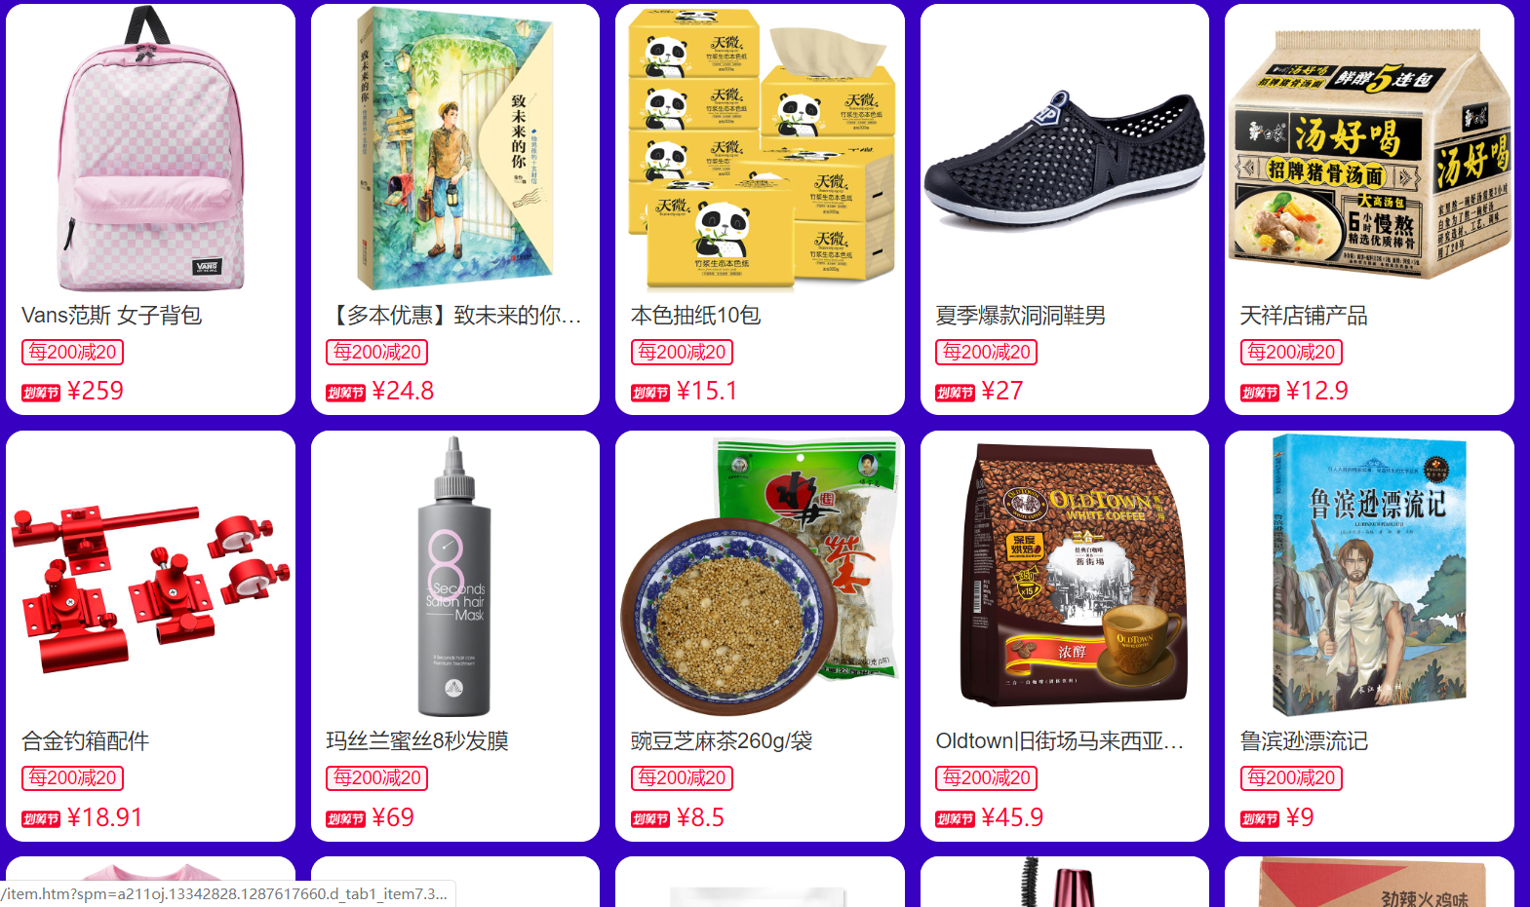

硅谷外卖

<https://github.com/W-Qing/Vue-MintShop>

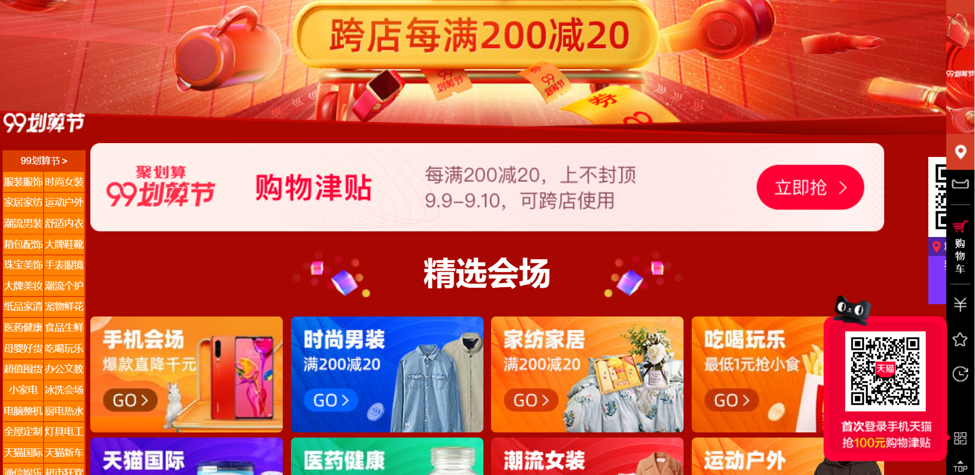

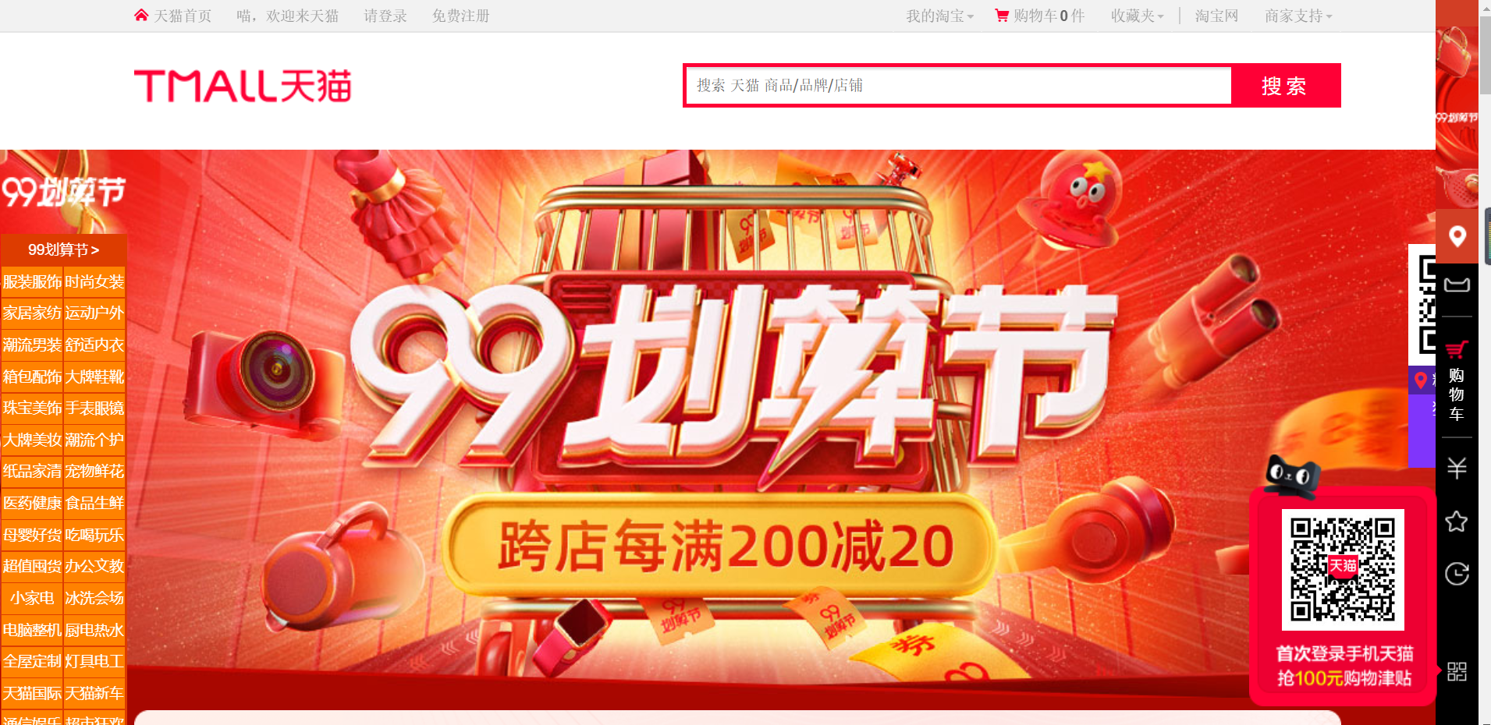

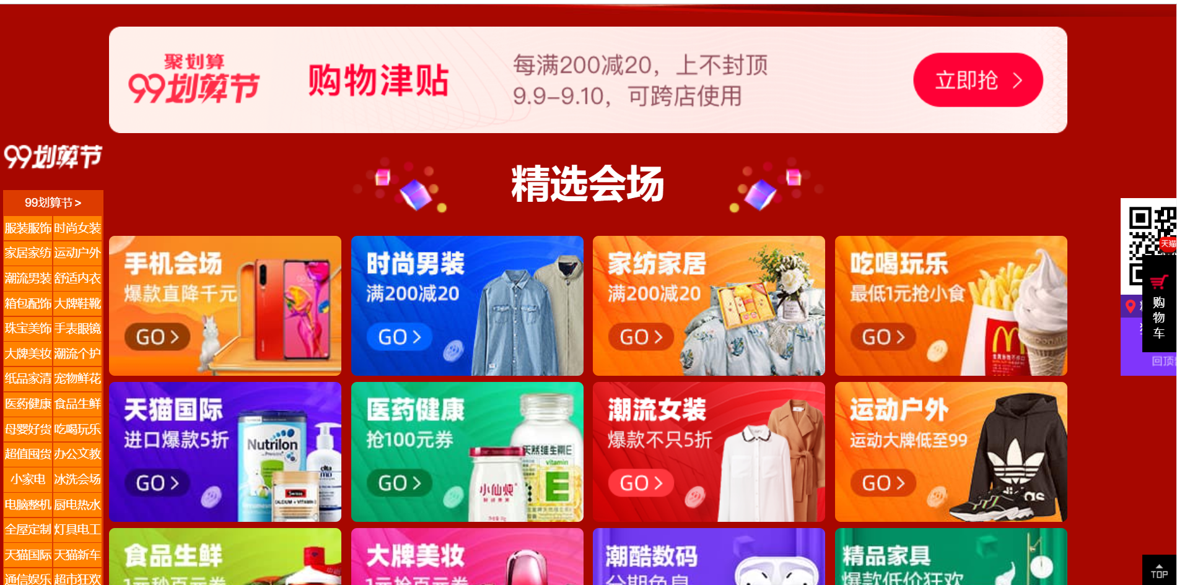

<https://github.com/hillmay2015/zks>

<https://blog.csdn.net/lyj2018gyq/article/details/82693921>

<https://github.com/macrozheng/mall-admin-web>

<https://blog.csdn.net/mashaokang1314/article/details/88904390>

